RESOLUTION NO.__________

RE: CERTIFICATE OF APPROPRIATENESS UNDER THE
PROVISIONS OF THE ACT OF THE PENNSYLVANIA
LEGISLATURE 1961, JUNE 13, P.L. 282 (53
SECTION 8004) AND BETHLEHEM ORDINANCE NO.
3952 AS AMENDED.

WHEREAS, it is proposed to replace an existing deck, add fencing and an arbor at 405 Center St.

NOW, THEREFORE, BE IT RESOLVED by the Council of the City of Bethlehem that a Certificate of Appropriateness is hereby granted for the proposal.

Sponsored by: (s)

(s)

ADOPTED BY COUNCIL THIS DAY OF

(s)
President of Council

ATTEST:

(s)
City Clerk

HISTORICAL & ARCHITECTURAL REVIEW BOARD

The applicant is proposing to replace an existing deck, add fencing and an arbor at 405 Center St.
APPLICATION #4:

Barbara Pearson
405 Center Street
Bethlehem, PA 18018

OWNER:

__________________________________________________________________________

The Board upon motion by Marsha Fritz and seconded by Nancy Shelly adopted the proposal that City Council issue a Certificate of Appropriateness for the following:

- New deck to have compliant riser heights.

- Deck to be Timber Tech with a non-slip finish.

- New fence to be cedar boards with a lattice top section stained.

- The arbor to match existing arbor design and materials already on site.

5. The motion was unanimously approved.
__________________________________________________________________________

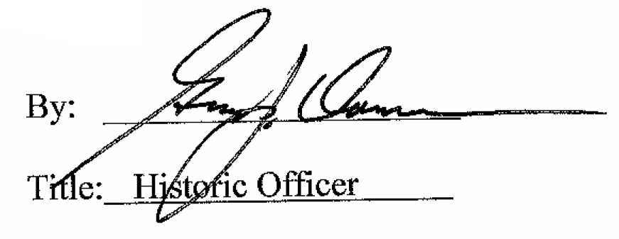

Date of Meeting: December 7, 2016

